Wendy Shaw

**Hamdi Bey, Osman** (1842-1910)

Osman Hamdi was the founding director of the Imperial Academy of Fine Arts (later renamed the Istanbul Academy of Fine Arts, today part of the Mimar Sinan University), the most powerful director of the Imperial Museum (today the Istanbul Archaeology Museum), an important arts legislator, the first Ottoman archeologist, and one of the most skillful and prolific painters of the Ottoman era. Osman Hamdi’s legacy persists in his numerous small-scale portraits of his cosmopolitan family and large-scale allegorical paintings that reflect on the relationship between Ottoman identity and European orientalist style. Often staging himself and his family members in anachronistic dress and in unlikely settings drawn from examples of early Ottoman architecture as well as the collections, his works offer an image of the Ottoman past replete with dignity and agency that contradicts Orientalist tropes such as laziness, violence, or lasciviousness. The complex juxtaposition of figures and objects often suggests a sharp sense of irony concerning the relationship between modernity and the past as staged through historicism offered both through the museum and through the Orientalist painting tradition. His most famous paintings include *The Man with the Tortoises* (1906; also known as *The Tortoise Trainer*) and *The Sharp Side of the Sword* (1908; also known as *The* *Weapons Merchant*)*.*

The son of Ibrahim Pasha, a high-level Ottoman administrator, Osman Hamdi began studying law in Paris in 1864, but discovered a passion for art while attending classes in the studios of Jean-Leon Gerome and Gustave Boulanger at the Ecole des Beaux Arts in Paris. After spending a year in Baghdad after his return to the empire, he became the Ottoman commissar at the Vienna Exhibition of 1873. In addition to overseeing the pavilions, he assisted in the preparation of two catalogues for the exhibit, *L’Architecture Ottomane* and *Les Costumes Populaires de la Turquie en 1873*. After the deposition of Sultan Abdülaziz in 1876, Osman Hamdi was appointed to the Directorate of the Foreign Press, then in 1877, as director of the Sixth Municipal District of Beyoğlu (the district with the highest concentration of Europeans, also known as Pera). The same year, following the sudden death of Antoine Déthier, director of the Imperial Museum, Osman Hamdi was appointed as its first Ottoman director. Taking advantage of a tip concerning the Sidon necropolis on the Mediterranean coast, in 1879 he directed the first Ottoman archaeological expedition, impeding European attempts to export works and acquiring a large enough collection of valuable sarcophagi, including one misidentified as that of Alexander the Great, to persuade the sultan to build a new Imperial Museum building in 1881. In 1881, Osman Hamdi applied to the government to open an art academy beside the museum, within the grounds of the Topkapı Palace. Replicating the structure of the Paris École des Beaux Arts, classes began in March of 1883. Reflecting his concern with preservation, in 1884 and 1906 Osman Hamdi wrote increasingly restrictive laws concerning the identification, processing, and export of antiquities to replace the initial law of 1874.

**References and further reading:**

Cezar, Mustafa. *Sanatta Batıya Açılış ve Osman Hamdi.* Istanbul: Erol Kerim Aksoy Kültür, Eğitim, Spor ve Sağlık Vakfı, 1995.

Edhem, Eldem. *Osman Hamdi Bey Sözlüğü*. Ankara: Republic of Turkey Ministry of Culture, 2011.

Shaw, Wendy M. K., *Ottoman Painting: Reflections of Western Art in the Ottoman Empire.* London: I. B. Tauris, 2011.

Image:

Osman Hamdi. *Man with Tortoises.* 1906. Oil on canvas, 117 x 223 cm. Suna and Inan Kiraç Foundation Collection.

Image

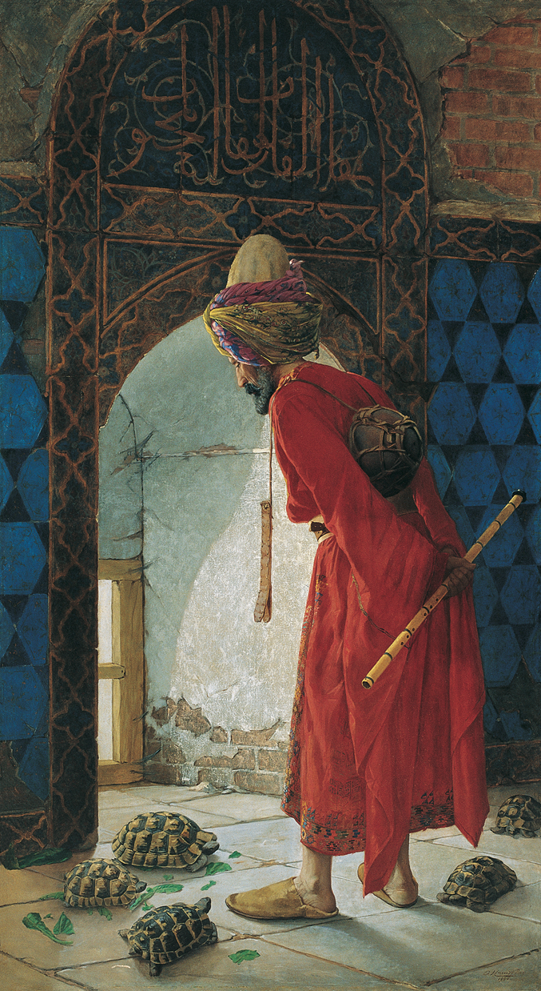

Osman Hamdi. *Man with Tortoises.* 1906. Oil on canvas, 117 x 223 cm. Suna and Inan Kiraç Foundation Collection.